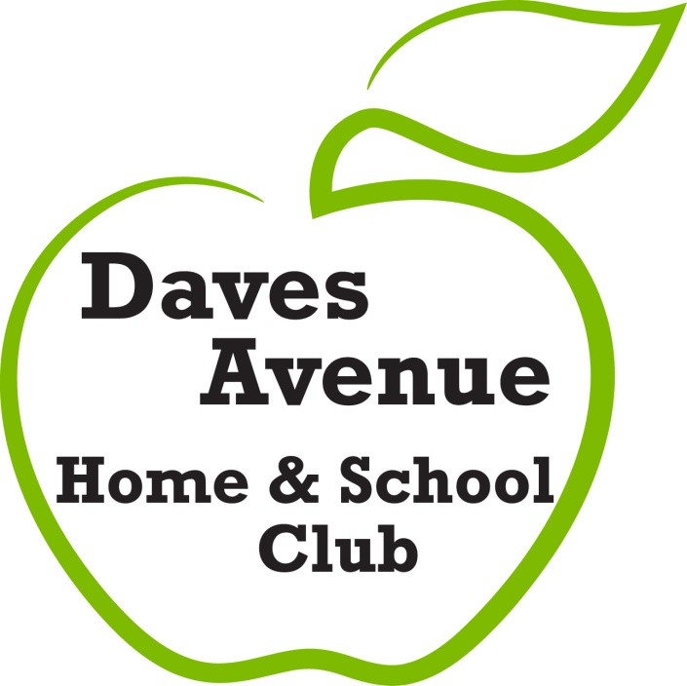
DAVES AVENUE ELEMENTARY SCHOOL
Annual Community Sponsorship Program
Sponsorship Form
Daves Avenue H&SC Tax ID #94-2786120
SPONSOR NAME:______________________________________________________
(please list name as you would like it to appear on signage and ad materials)
ADDRESS:__________________________________________________________
PHONE:__________________________ EMAIL:___________________________
SPONSORSHIP LEVEL:________________ AMOUNT $:______________

PLEASE RETURN THIS FORM BY SEPTEMBER 16th TO ENSURE LOGO/Company name IS ON FUNWALK T-SHIRT:
Daves Avenue Elementary School
ATTN: H&SC – Bryce Wend and Nicole Reginelli
17770 Daves Avenue Monte Sereno, CA 95030
QUESTIONS? Please contact:
Bryce Wend … 415.850.2139 or brycewend@gmail.com
Nicole Reginelli … 408.438.0375 or nreginelli@mac.com

