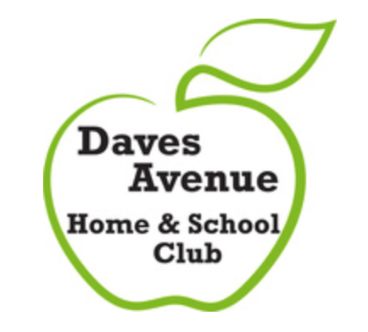
Daves Avenue Home & School Club Meeting Minutes
February 4, 2016

Daves Avenue School, Los Gatos, California

In attendance
Andrea Anderson, Nava Bernstein, Rachel Black, Kit Bragg, Emelia Cellura, Uma Chakravarthy, Shannon Drotar, Michele Grancell, Cathy Guenther ,Becky Hanson, Ali Hasha-Olivo, Carolyn Harnish, Donna Leu, Cathy McDonald, Jeff Milde, Kristin Owens, Heather Gaede Regoli, Nicole Reginelli, Kim Simon, Dan Snyder

- The meeting was called to order by Nicole Reginelli at 8:30am.
- Approval of January 7, 2016 Minutes
  - Motion: Jeff Milde
  - Second: Dan Snyder
  - Motion Passed

- Treasurer’s Report- Kim Simon: Approval of $130,500 grant for literacy and math specialists, health clerk, and physical education in the 2016-17 school year.
  - Motion: Carolyn Harnish
  - Second: Donna Leu
  - Motion Passed
- President’s Report- Nicole Reginelli
  - Shout Outs
    - Fourth and Fifth Grade Play
    - Bingo Night
    - Authors’ Day
    - Science Fair
    - Adult Auction
    - Ongoing programs
  - Facilities Advisory Task Force has an opening; contact Nicole if interested.
- Executive Board
  - Vice President- Carolyn Harnish
    - Volunteer Information Wine and Cheese Night
      - For anyone interested in filling or recruiting for a chair or coordinator role
      - Enoteca on Tuesday, March 1
      - Open Chairs: Fifth Grade Party, Authors Day, Bingo Night, Free2Me, Funvisors, Fun Walk, LGEF Captain, Memory Book, Moms’ Night Out, New Family Liaison, Spirit Wear
    - Wednesday Wave:
      - Please provide content by Friday at noon each week
      - Question: Should Wednesday Wave be more phone-friendly? Add question to next parent survey.
- Committee Reports
  - Los Gatos Education Foundation- Becky Hanson & Kristin Owens
    - Have raised enough ($612,000) to cover personnel grants for next year. Still need to raise additional funds for Foss Kits and art supplies.
    - Considering change in funding model going forward. Other comparable foundations raise more money, but tend to support staff as opposed to supplies.
  - Adult Auction – Jeff Milde
    - March 19 – Cool Cat Auction at Testarossa (formerly known as the Circus)
    - Registration just opened; deadline for early-bird pricing is February 29.
    - Tickets are $60 per person if you are One & Done and $120 per person if you are not. Includes valet parking, three hours wine service, food, and disc jockey until 11pm. Will have both new and familiar features.
    - Ready Set Auction: an online software service for nonprofit auctions, making check-in and check-out easier.
    - Need volunteers to help on the night of the auction and in advance.
  - Bingo Night- Heather Gaede Regoli for Isabel Guerra
    - Need more donations of prizes and baked goods.
    - Advertising through Wednesday Wave, posters, a table at pick-up, and an email blast to parents.
    - Everything on schedule.
  - Safe Routes to School – Nicole Reginelli for Donna Leu
    - Vision Zero: A town-wide vision for reducing deaths on our roads. Informational meeting at Blossom Hill on Thursday, February 11.
    - Dan Synder: Town is currently studying flow of pedestrian and bike traffic.
  - Spirit Wear- Cathy McDonald: Daves Avenue socks will be on pre-sale at Bingo Night.
- Principal’s Report- Kit Bragg: Silicon Valley Math Initiative’s Open House was at Daves last Thursday. Attended by two counties, twenty districts, and seventy teachers. Two Daves teachers and their classes demonstrated to attendees techniques of math journaling and teaching through problem solving.
- Old Business
- New Business
Adjournment at 9:15am

